CELL DIVISION

Mitosis

Mitosis produces new cells for growth and to replace damaged cells.

It occurs for all cells except for the reproductive cells (sperm and egg cells).

One cell divides many times and each cell produced will be an exact copy of the one cell with all cells having the same number of chromosomes.

The nucleus controls the division process.

The steps involved in this process are shown below.

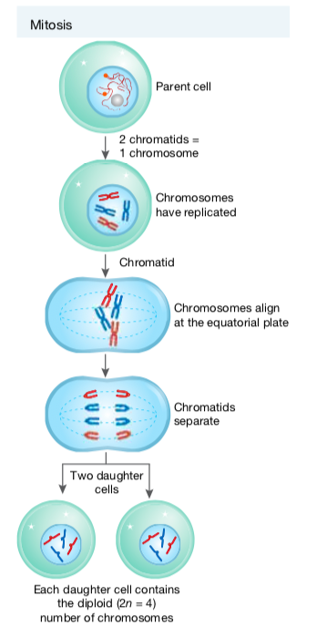
When the chromosomes first become visible and then duplicate themselves, they form two chromatids that are joined by a centromere.

This still represents one chromosome only, not two.



The result of mitosis is that the daughter cells all contain the normal number of chromosomes.

Definitions

Diploid Number - normal number of chromosomes.

Haploid Number - half the normal number of chromosomes.

Meiosis

This occurs in the reproductive organs and produces gametes with the haploid number of chromosomes (half the normal number).

This is important as during the fertilisation process between an egg and sperm cell, the diploid or normal number of chromosomes is restored.

The process occurs in two stages.

STAGE 1 - the chromosome number is halved.
STAGE 2 - the chromosomes are pulled apart as in mitosis.

The process occurs as shown below.
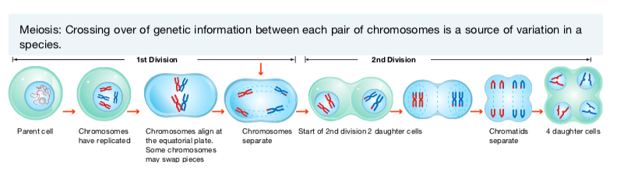
Definition

Homologous Pair - two chromosomes containing similar genetic information for particular
characteristics.

